# MINI PROJECT II

# (2020-21)

**WeTube**

**FINAL REPORT**



**Institute of Engineering & Technology**

**Submitted by-**

**Aditya Kumar Das (181500041)**

**Gaurav Kumar (181500233)**

**Prashant Verma (181500493)**

**Pulkit Ranjan (181500519)**

**Vishes Keshari (181500813)**

***Supervised By:***

**Mr. Vinay Agrawal**

Technical Trainer

# Department of Computer Engineering & Applications

|  |
| --- |
| **TABLE OF CONTENTS** |
| **Certificate 4**  **Synopsis 9**  **Acknowledgement 11**  **Abstract… 12** |
| **1. Introduction….…………………………………………………………….** |
| 1.1 Overview 13 |
| 1.2 Motivation 14 |
| 1.3 Problem Statement 15 |
| 1.4 Objective… 15 |
| **2. Software Requirement Analysis…………………………………………..** |
| 2.1 System Analysis 16 |
| * 1. Users 17 |
| 2.3Methodology 17   * 1. Dependencies /External Systems 18   2. Use-case Diagram 20 |
| 1. **Implementation details 21** 2. **Contribution Summary 22** |

|  |
| --- |
| 1. **Project Work 23** 2. **Future Scope… 51** |
| **Reference 51** |

**Certificate**

This is to certify that Aditya Kumar Das, Gaurav Kumar, Pulkit Ranjan, Prashant Verma and Vishes Keshari students of B.Tech (CSE) 3rd year has successfully completed the **MINI PROJECT-II** named **WeTube** on Web Development under the Guidance of **Mr. Vinay Agrawal** During 2020-21.

Signature:

**Mr. Vinay Agrawal** (Mentor)

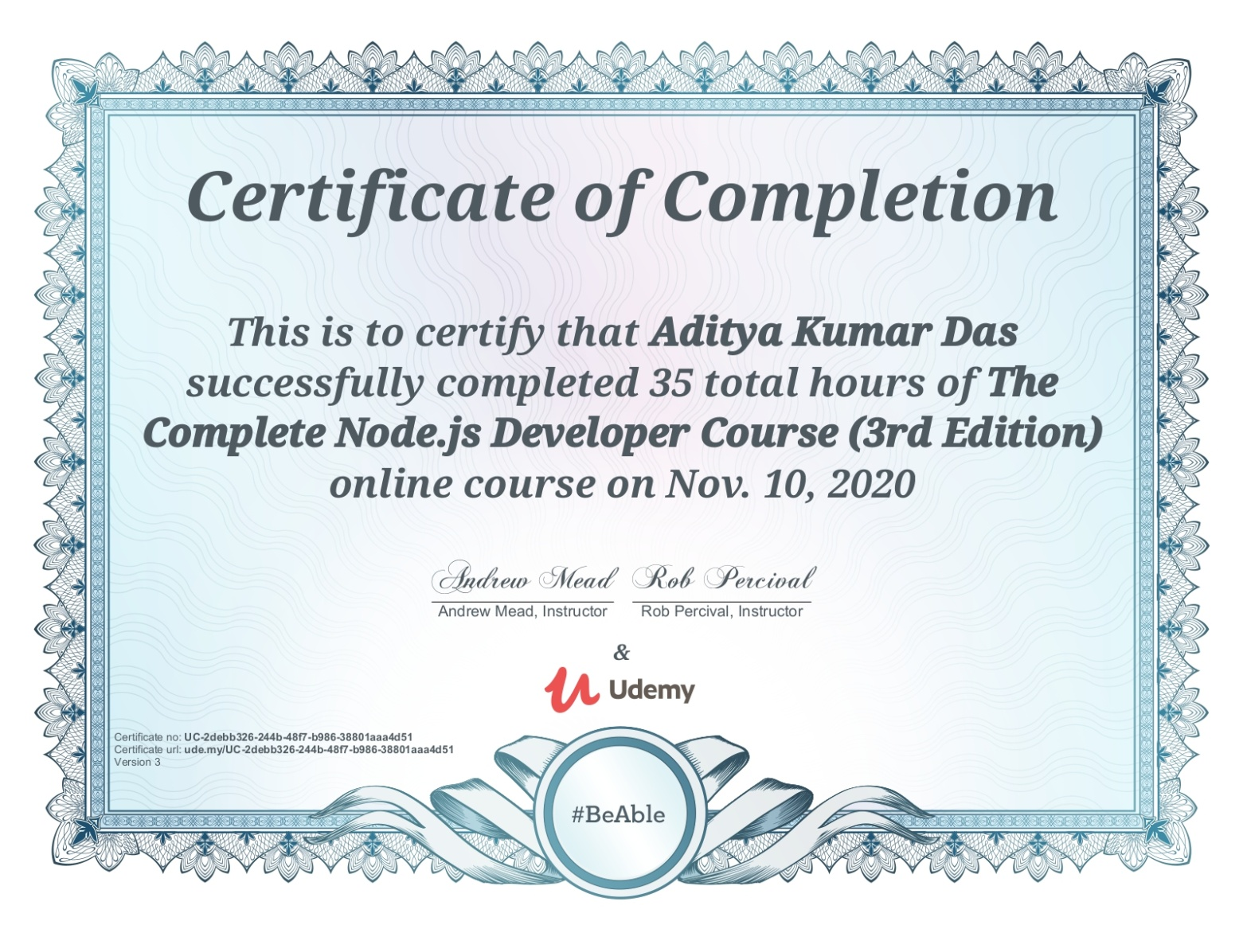



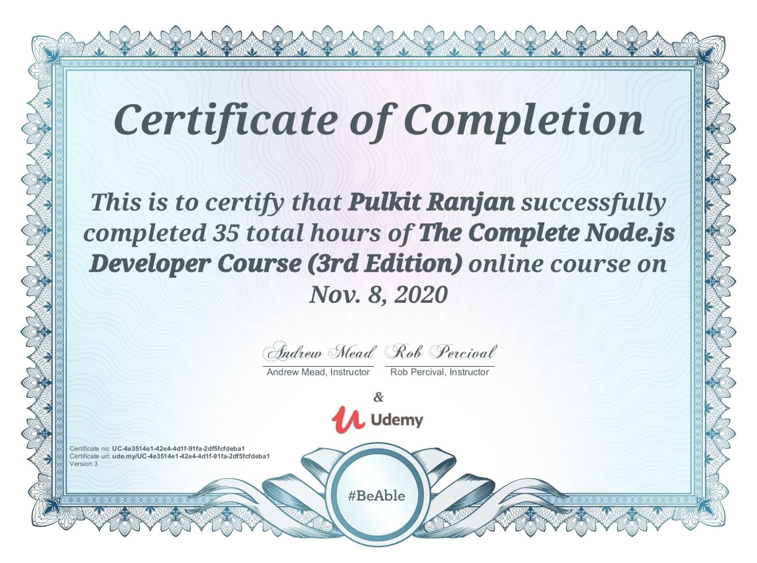

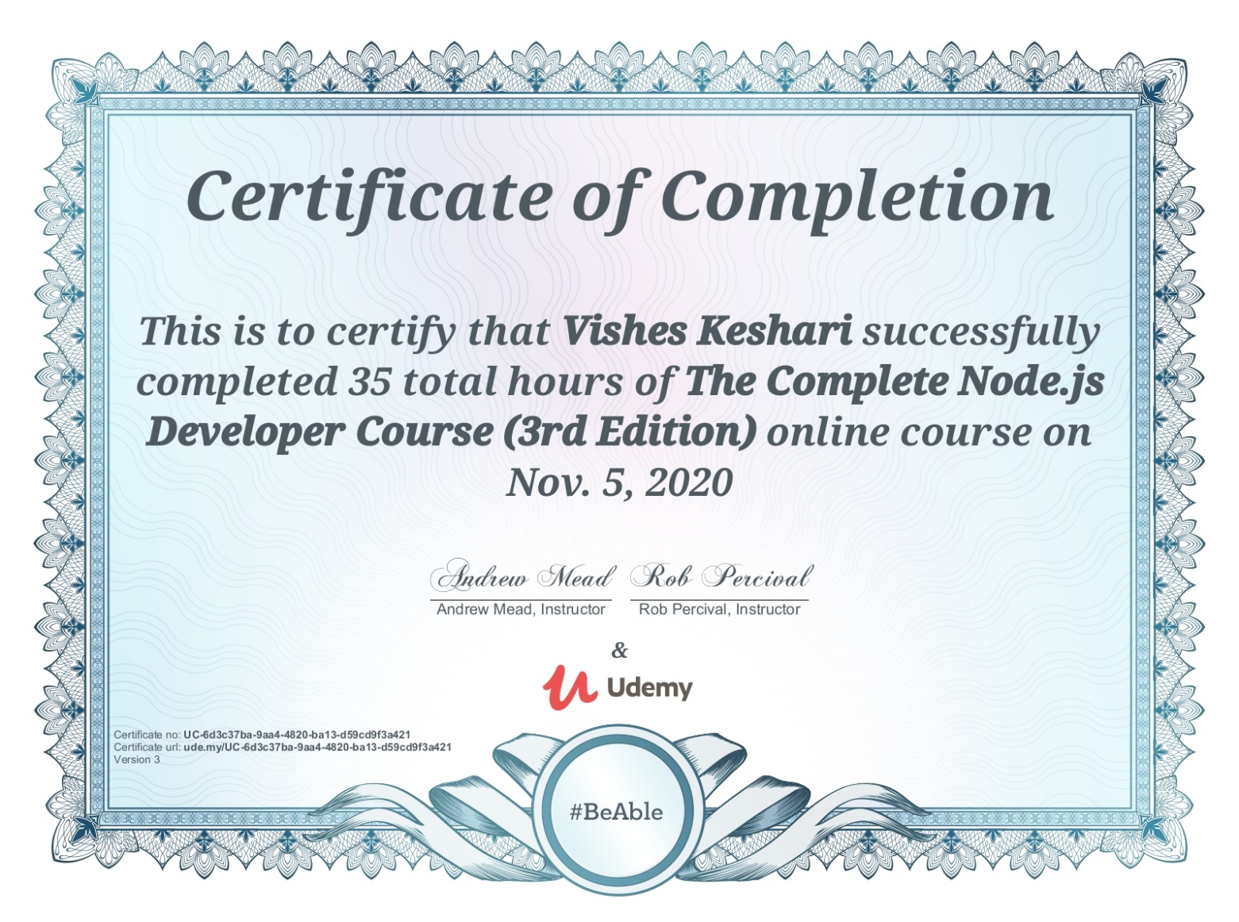



**MINI PROJECT-II Synopsis**

**B.Tech. (CSE)-Batch 2018-2022**

Project Information:

|  |  |
| --- | --- |
| Title of Project/Training/Task | WeTube |
| Role & Responsibility | Aditya Kumar Das: Project Setup, Home screen User Interface.  Gaurav Kumar: React Router Setup, Redux setup, Firebase Authentication, Private Route.  Vishes Keshari: Categories bar, Pagination, Most Popular Videos, Loading Skeleton, Lazy Load Images  Pulkit Ranjan: Watch Screen, Video player and details, Channel details, Comments.  Prashant Verma: Related videos, Search screen, Subscription screen. |
| Technical Details | Hardware Requirements:   * 2 GB RAM * 20 GB OF HARDDISK * Processor i3 (7th Gen) * Internet connection   Software Requirements:   * Technology Implemented: React, Redux, Firebase and YouTube API, Node.js * Language Used: HTML, CSS, JavaScript * Web Browser: Google Chrome (Version: 84.0.4147.135 or above*)* * Code editor: Windows Visual Studio *(*Version:16.0 or above*)* |

**Summary of the Work:**

During the completion of this project WeTube we learnt about React, Redux, Firebase, HTML5, CSS, JavaScript, Node.JS and API’s.

1. **Aditya Kumar Das:**

* Project Setup
* Home screen User Interface.

1. **Gaurav Kumar:**

* React Router Setup
* Redux setup
* Firebase Authentication
* Private Route.

1. **Vishes Keshari**:

* Categories bar
* Pagination
* Most Popular Videos
* Loading Skeleton
* Lazy Load Images

1. **Pulkit Ranjan:**

* Watch Screen
* Video player and details
* Channel details
* Comments.

1. **Prashant Verma:**

* Related videos
* Search screen
* Subscription screen.

**Acknowledgment**

We have taken efforts in this project. However, it would not have been possible without the kind support and help of many Teachers. I would like to extend my sincere thanks to all of them.

We are highly indebted to Mr. Vinay Agrawal for his guidance and constant supervision as well as for providing necessary information regarding the project & also for his support in completing the project.

We would like to express my gratitude towards our parents & member of GLA University for their kind co-operation and encouragement which help us in completion of this project.

## Abstract

The report presents the three tasks that is being in continuation during college time at GLA University which are listed below:

1. Understanding of the Problem objective & implication.
2. Understanding of the data & building of the model.
3. Evaluation of the model.

All these tasks have been completed successfully and results were according to expectations. All the tasks were need very systematic approach, starting from the collection of the data to the implementation of the solution and till evaluation of the System. The most challenging task was the domain knowledge, to understand the language. It is one of the major areas and really need very fundamental and conceptual knowledge of React, Redux, Firebase, HTML, SCSS, JavaScript, Node.JS and API’s.

# Introduction

* + Overview

All the functional/non-functional requirements, corresponding Use Case Diagrams have been organized in this report. Along with these designs, this report also contains the essential data of this project.

* The Our project WeTube is a video streaming media web application which very similar to YouTube. It is a multi-platform application and can be used by many users.
* WeTube web application has features such as:
* Login through google account.
* Homepage UI
* Categories Bar
* Data about videos (number of likes, views and dislikes)
* Data about channel (icon, description, subscriptions, videos)
* Ability to post comments
* Ability to share videos
* Feature to save videos to watch later.
* Related Videos and Up-next videos
* Ability to search videos and channels
* Responsiveness and Pagination

**Motivation**

In current scenario, Major advancements in technology have drastically changed how and where we share information, showcase our talent, conduct business, Advertise, entertain people or Educate the world with more people working remotely, the rise of instant, on-demand and cheap platform for communications and the globalization of information was inevitable. With many students using smart phones, video is a great platform to reach them.

WeTube is a video streaming web application solution to build a website similar to YouTube. It is designed to boost simplicity to both service providers and users.

WeTube web application has features such as Login through Google account, browse and search desired videos, add videos to watch later section, allow user to post their comments on them and provide option to share videos, etc.

**Problem Statement**

The project is to create a video streaming web application service where users can watch, share, comment on videos posted by other users and get the data about videos, channel and subscription.

**Objective**

* To create a responsiveness video streaming media web application with UI similar to YouTube.
* Users can watch, share and post comment on videos.
* User can save videos to watch later.
* Users can watch videos posted by other users and upload videos of their own.
* Login through google account.
* User can filter the recommendation using Categories Bar
* User can monitor the data about videos like number of likes, views and dislikes.
* Also, data about channel like its description, subscriptions, videos and main icon.
* This application also recommends user related videos and show up-next videos.
* Give user ability to search videos and channels
* Application must support Pagination

**System and Requirement Analysis**

* 1. **System Analysis**

System analysis is a process of collecting and interpreting facts, identifying the problems, and decomposition of the system into its components.

It is a process of studying a system in order to define its goals or purposes and to discover operations and procedures for accomplishing them most efficiently.

For modern and innovative businesses to grow and globalize, building and maintaining quality relationships with partners, suppliers, internal teams, investors and customers is essential. Video conferencing boosts productivity, saves time, reduces travel expenses, and overall promotes collaboration. The advantage of video conferencing is the ability to facilitate all of those benefits without requiring constant travel for face-to-face communication

### **Users**

The User of the web application would be people all around the world who want to stream videos linked with their YouTube account via YouTube Data API.

### **Methodology**

* First, we will work on making design for our website using pencil wireframe.
* Next, we will Initialize our NodeJS Project.
* Download important packages like React-Bootstrap, Bootstrap (main), Node-SASS (version 4.14.1), React-icons.
* Then we create our React Application.
* We then create and design our Home Screen UI.
* Then we do React Router Set Up
* Then Redux setup
* Then Firebase authentication.
* Then we do Private Route.
* After these we create our Categories Bar
* Then we add most popular videos feature
* We then make this WeTube application support Pagination (infinite scroll)
* Then we build loading skeleton and add lazy load images
* Then we setup our watch screen, video player and give ability to see details of video and channel.
* Then we add the feature to post comment on videos.
* After these we create additional features like related videos and up-next videos.
* Then we setup Search screen.
* And then finally Subscription Screen and in that ability to stream videos of any particular channel.

### **Dependencies/External Systems**

**User Interfaces:**

In the WeTube web application, there are options that allow you to:

* + Stream videos.
  + Post a comment.
  + Save a video to watch later.
  + Browse through channels.
  + Sign in with google account.

**Hardware Interfaces:**

The application will require a system with an active internet connection.

**HARDWARE REQUIREMENT (MINIMUM)**

* 2 GB RAM
* 20 GB OF HARDDISK
* Processor i3 (7th Gen)
* Internet

**SOFTWARE REQUIREMENT-**

* Technology Implemented: React, Redux, Firebase and YouTube API, Node.js
* Language Used: HTML, CSS, JavaScript
* Web Browser: Google Chrome (Version: 84.0.4147.135 or above*)*
* Code editor: Windows Visual Studio *(*Version:16.0 or above*)*

**USE DIAGRAM**

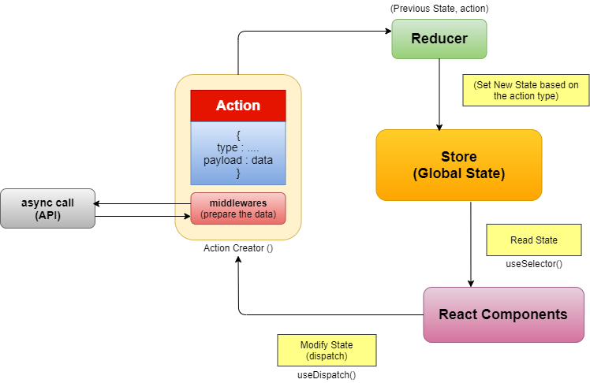

**Implementation Details**

* First, made design for our website using pencil wireframe.
* Next, we initialized our NodeJS Project.
* Then downloaded important packages like React-Bootstrap, Bootstrap (main), Node-SASS (version 4.14.1), React-icons.
* Then we have created our React Application.
* We then created and designed our Home Screen UI.
* Then we did React Router Set Up
* Then Redux setup.
* Then Firebase authentication.
* Then we made Private Route.
* After these we created our Categories Bar
* Then we added Most Popular videos feature
* We then made this WeTube application support Pagination (infinite scroll)
* Then we built loading skeleton and add lazy load images
* Then we did setup of our watch screen, video player and give ability to see details of video and channel.
* Then we added the feature to post comment on videos.
* After these we created additional features like related videos and up-next videos.
* Then we did setup Search screen.
* And then finally Subscription Screen and in that ability to stream videos of any particular channel.

### **Contribution Summary**

1. **Aditya Kumar Das:**

* Project Setup
* Home screen User Interface.

1. **Gaurav Kumar:**

* React Router Setup
* Redux setup
* Firebase Authentication
* Private Route.

1. **Vishes Keshari**:

* Categories bar
* Pagination
* Most Popular Videos
* Loading Skeleton
* Lazy Load Images

1. **Pulkit Ranjan:**

* Watch Screen
* Video player and details
* Channel details
* Comments.

1. **Prashant Verma:**

* Related videos
* Search screen
* Subscription screen.

**Project Work:**

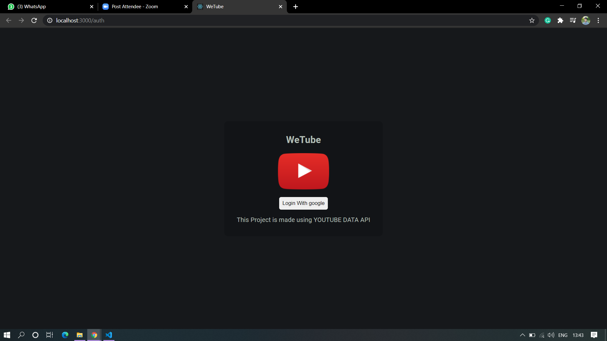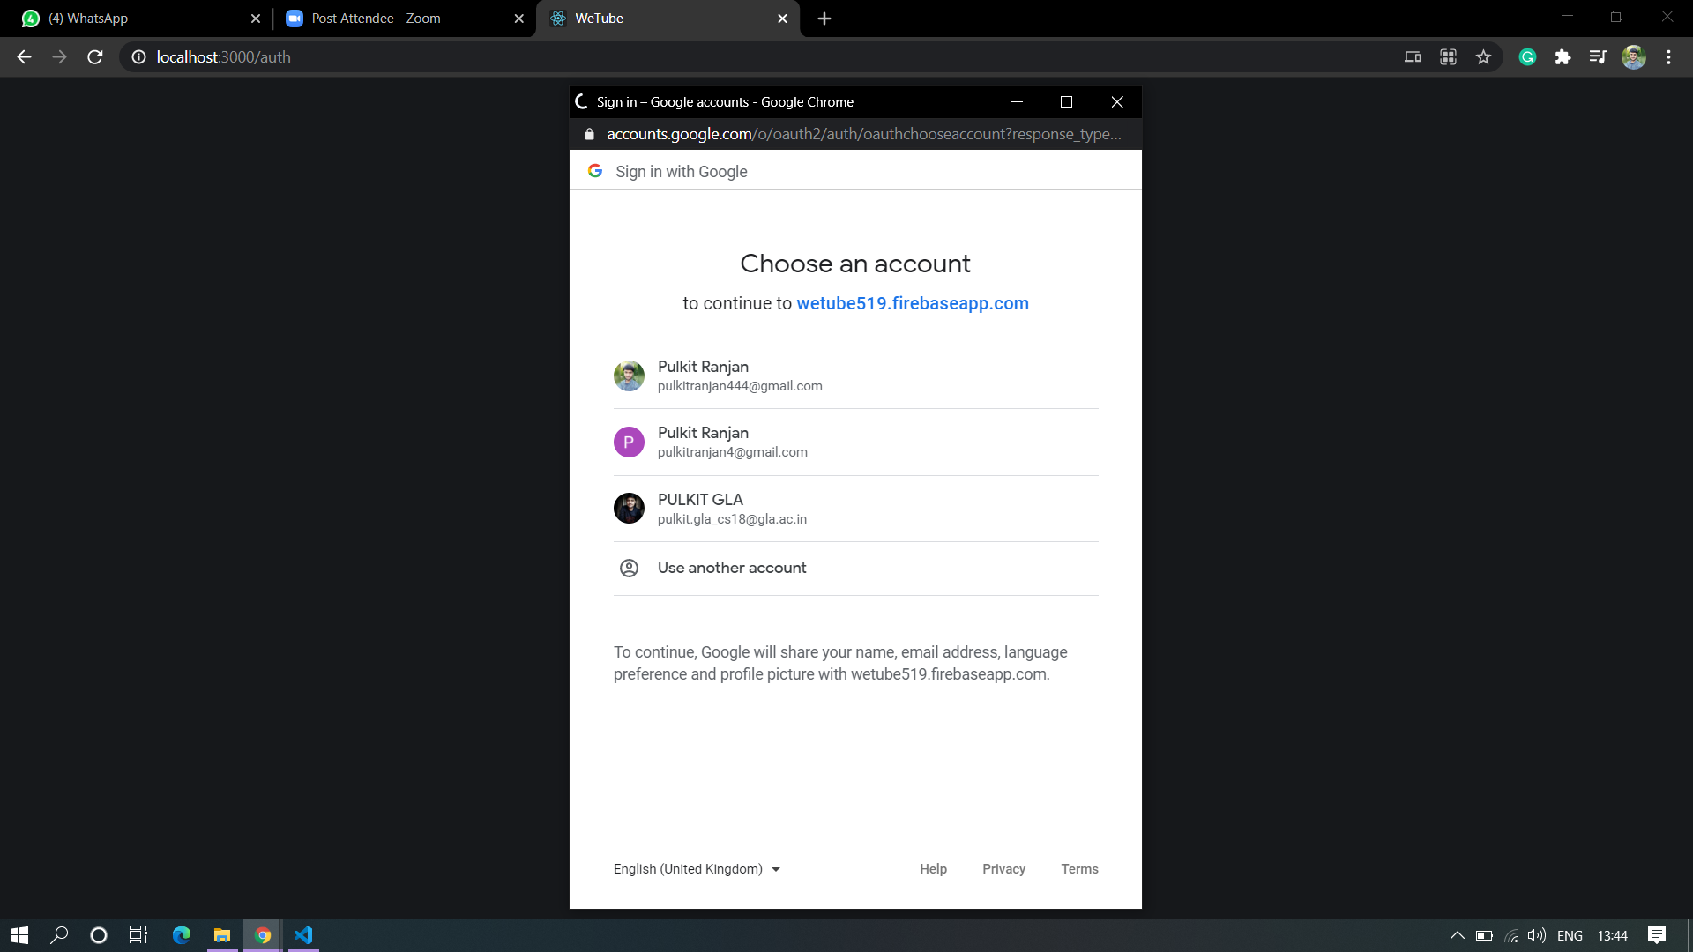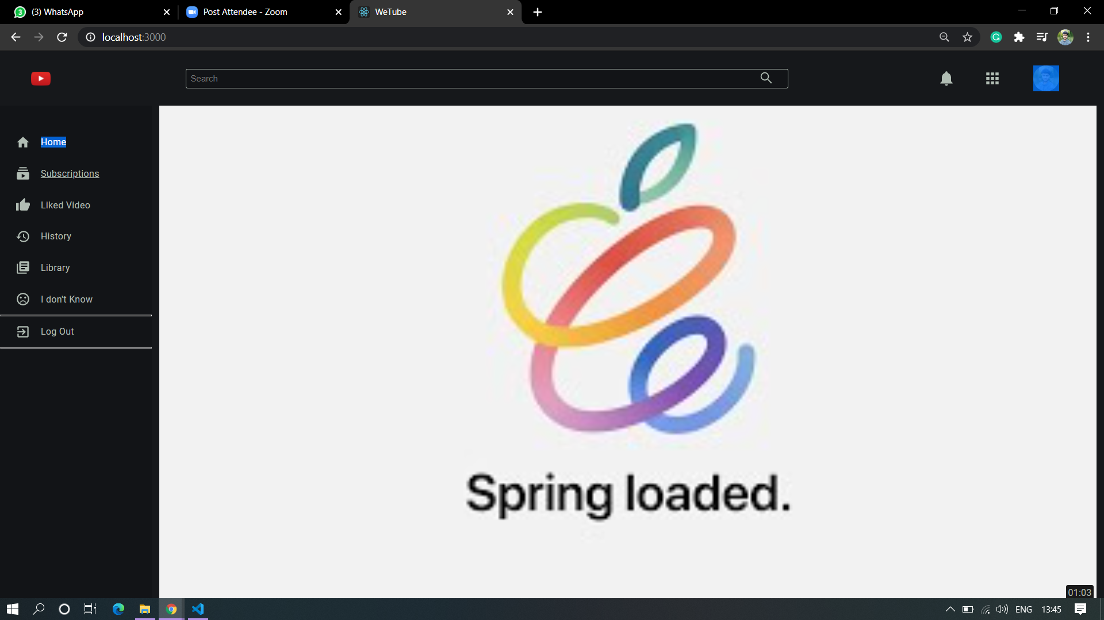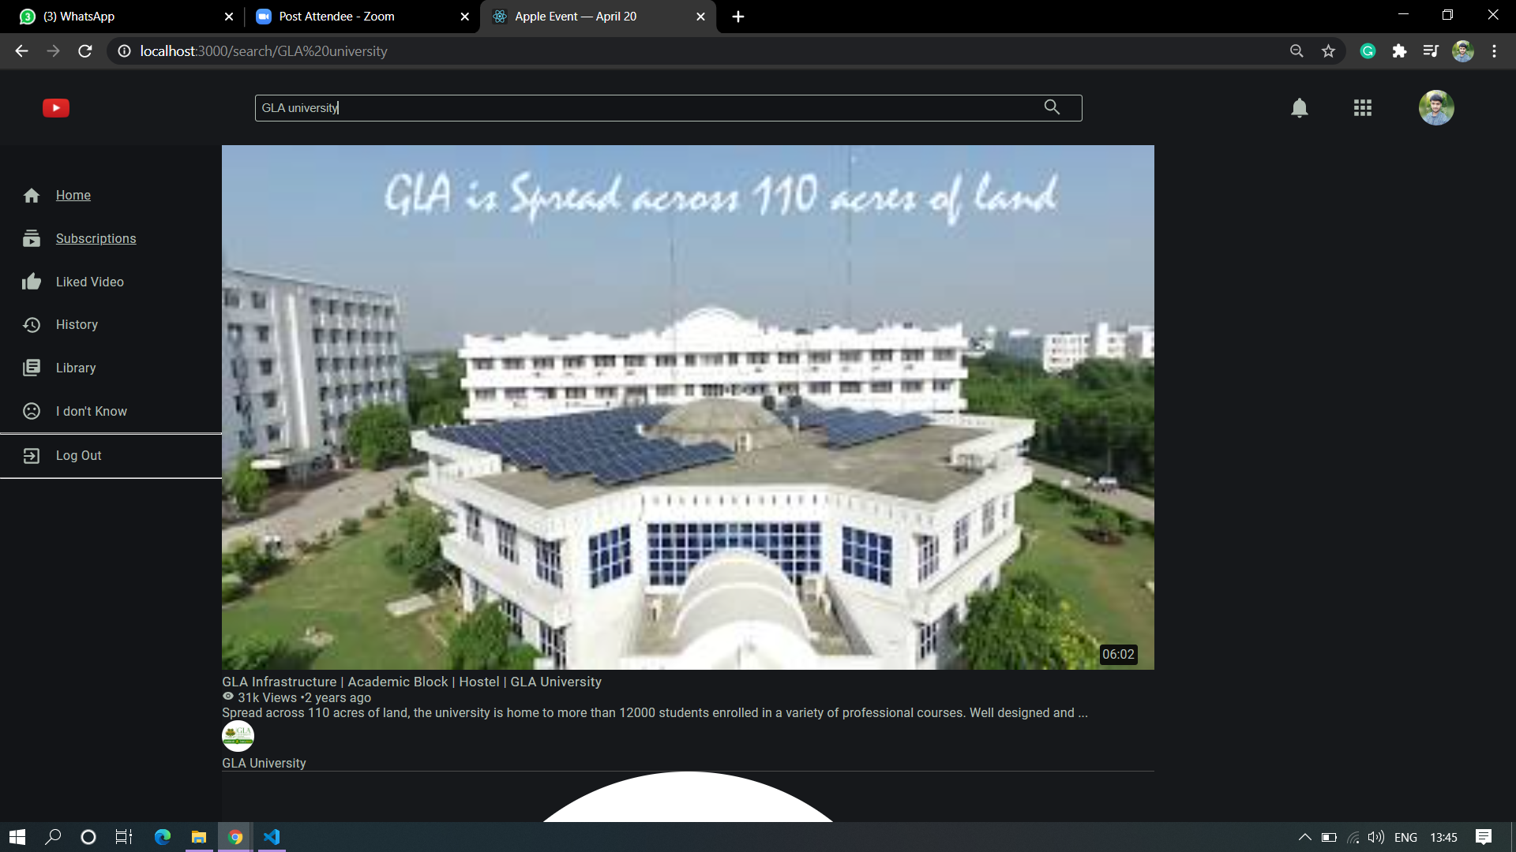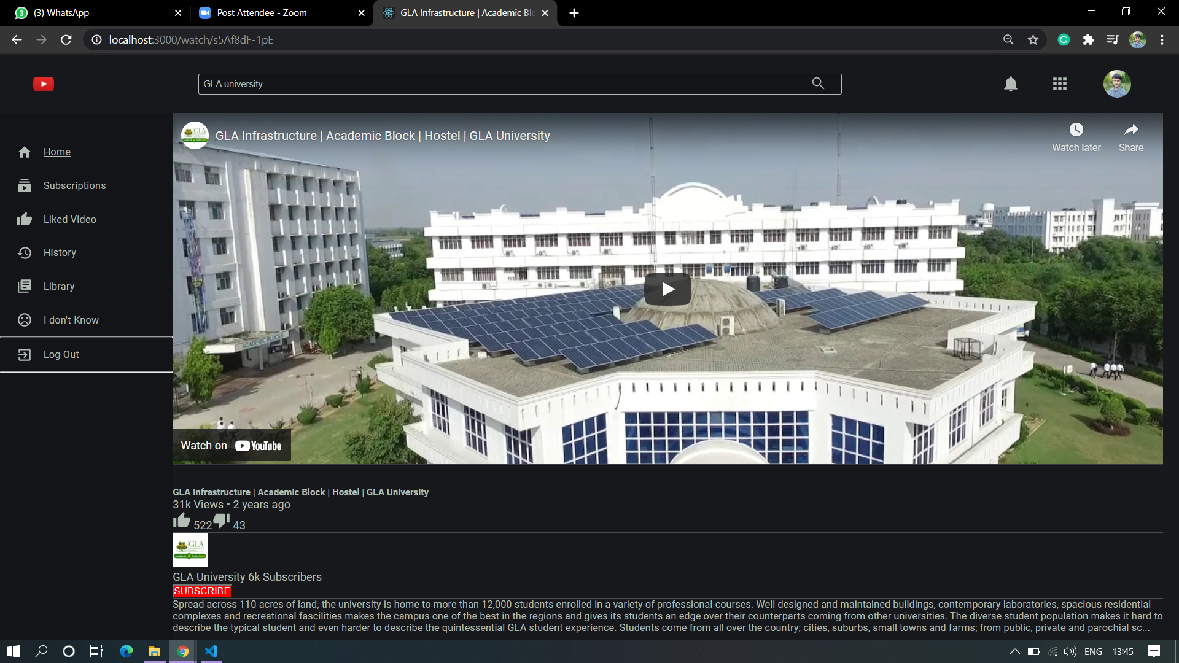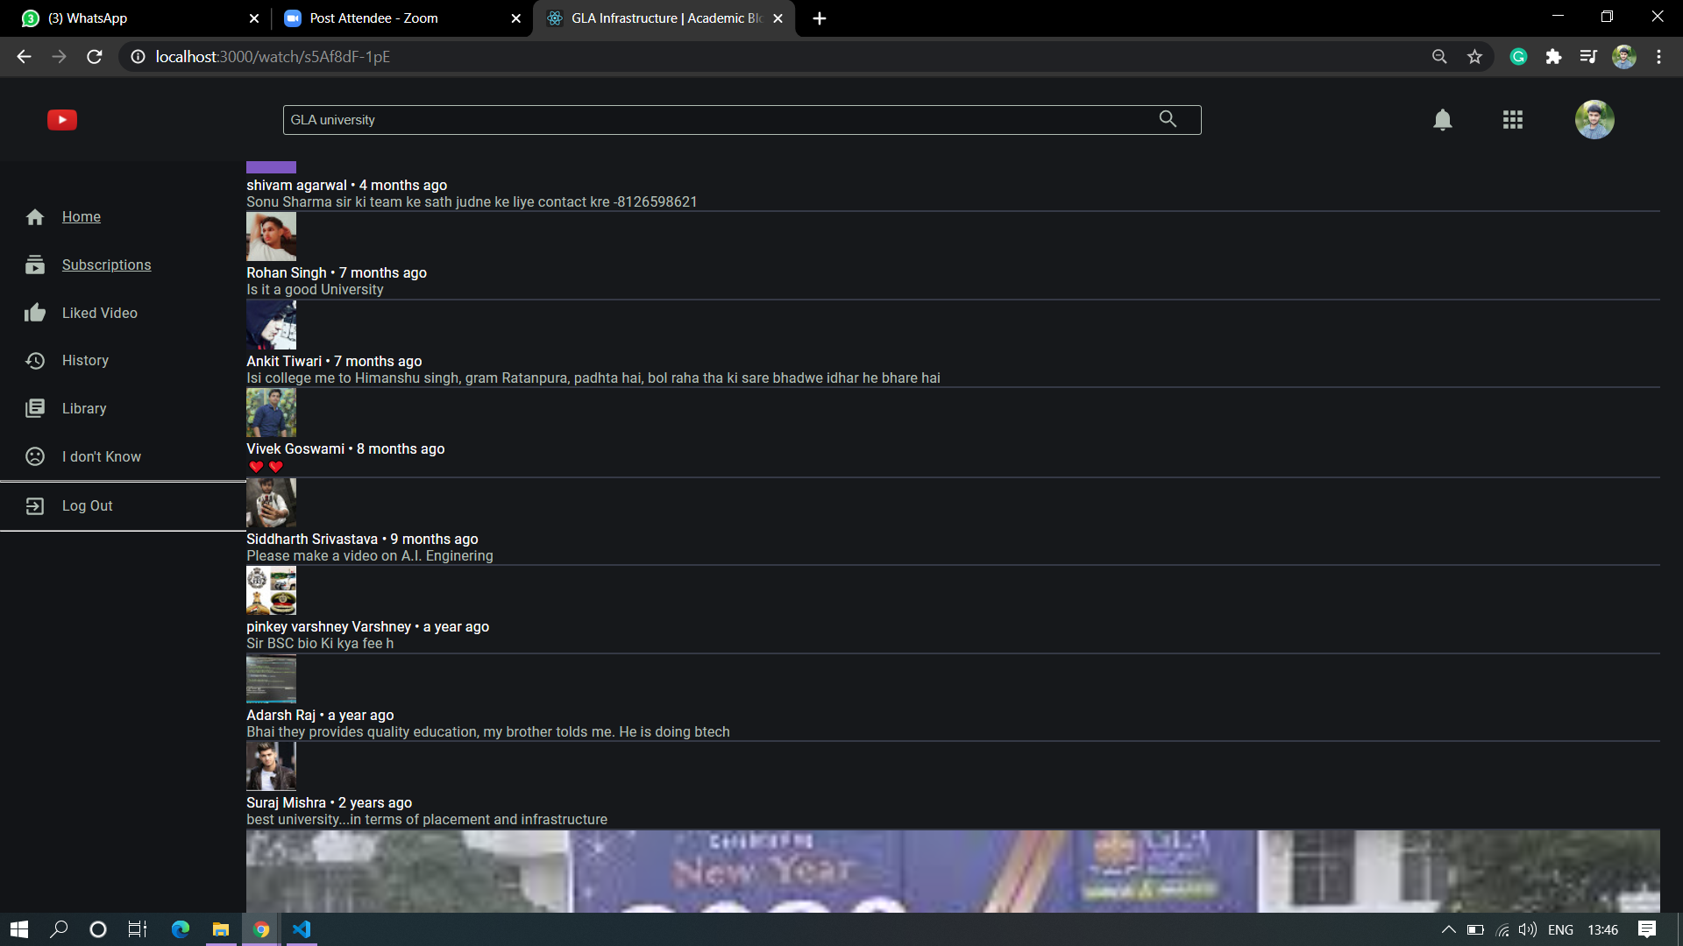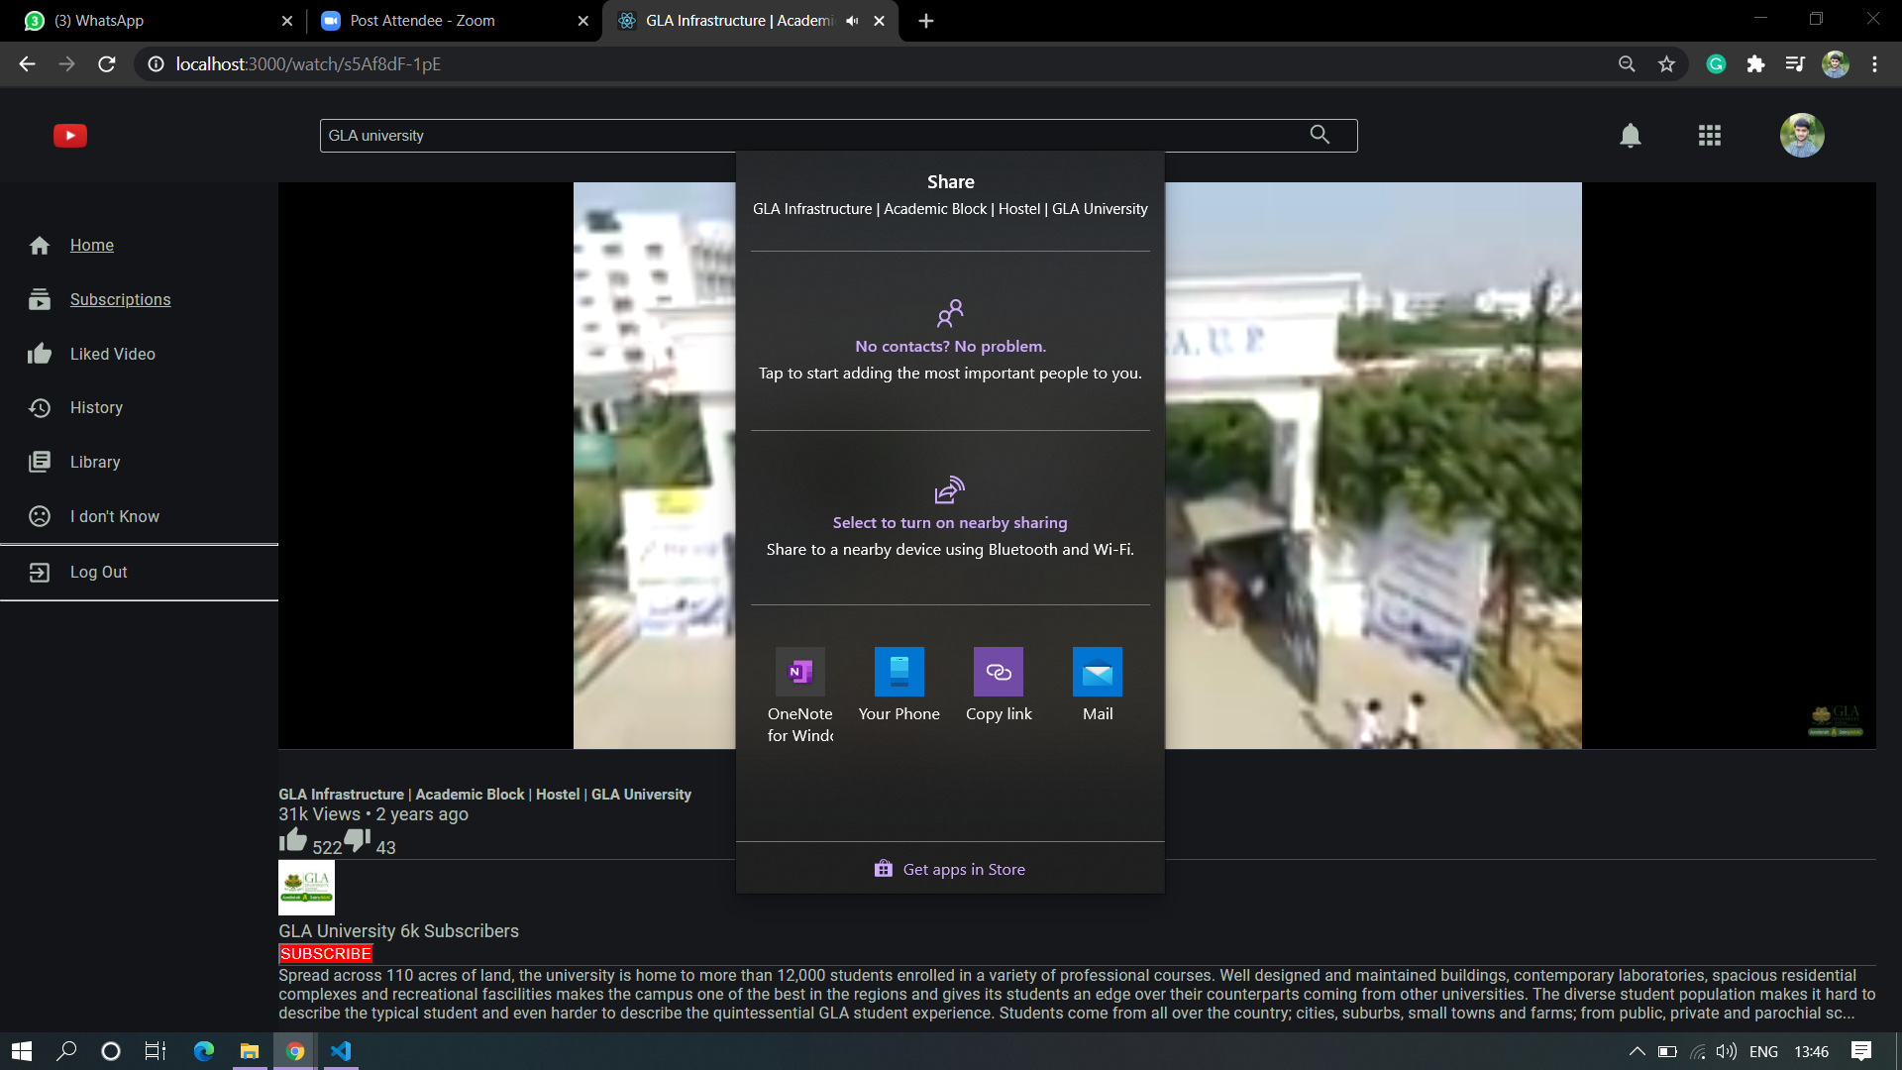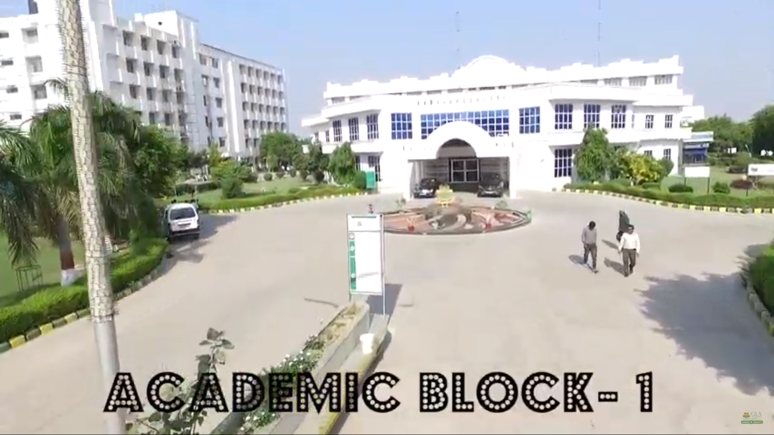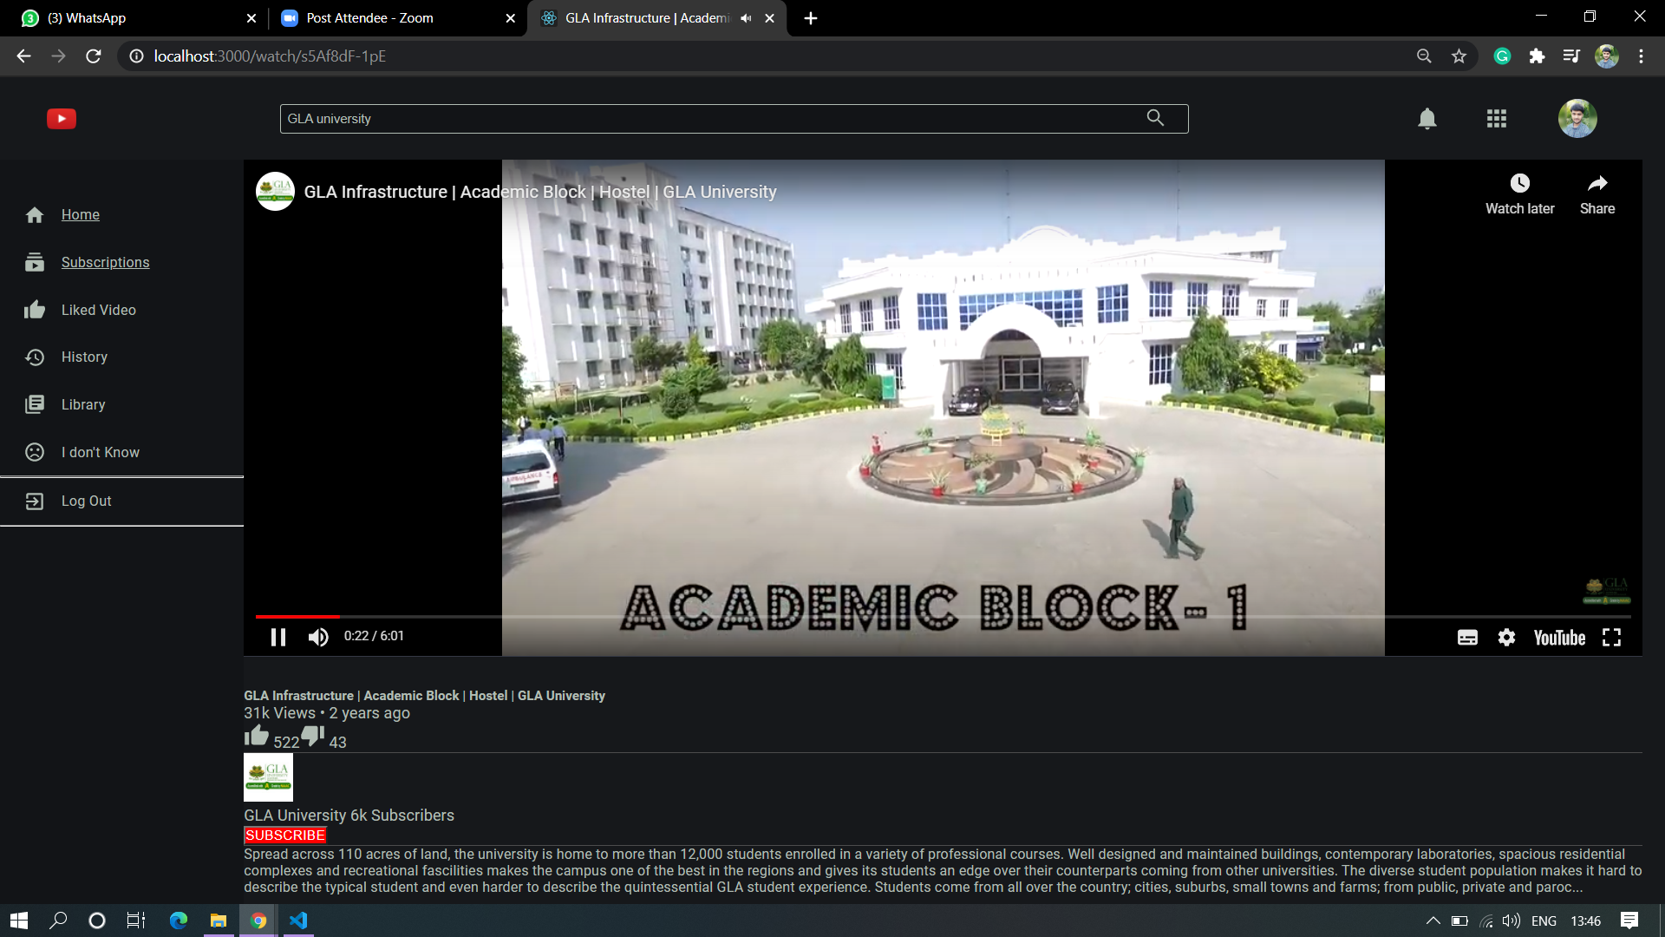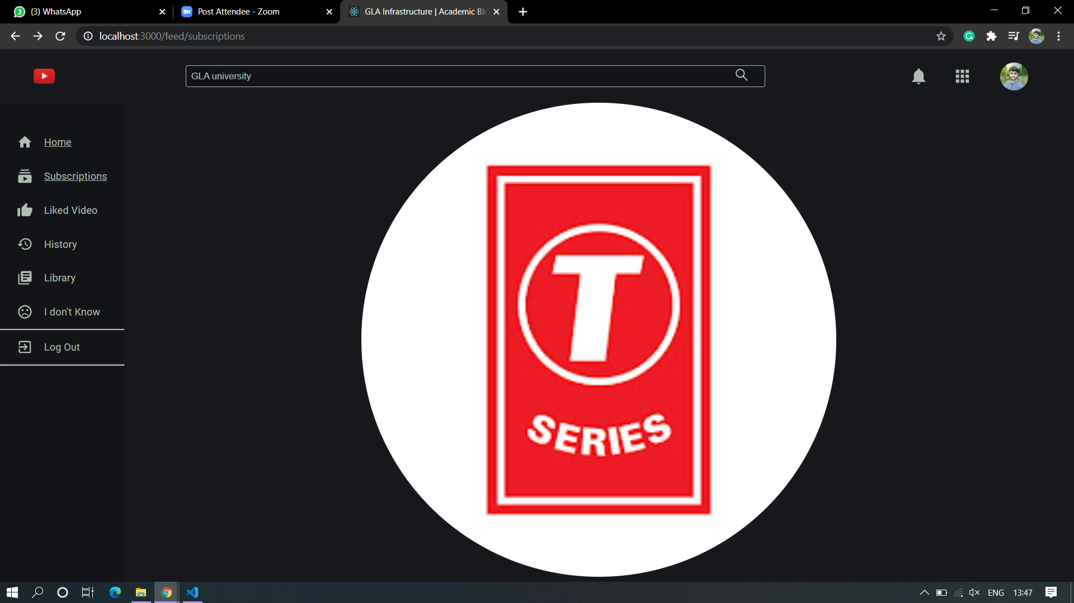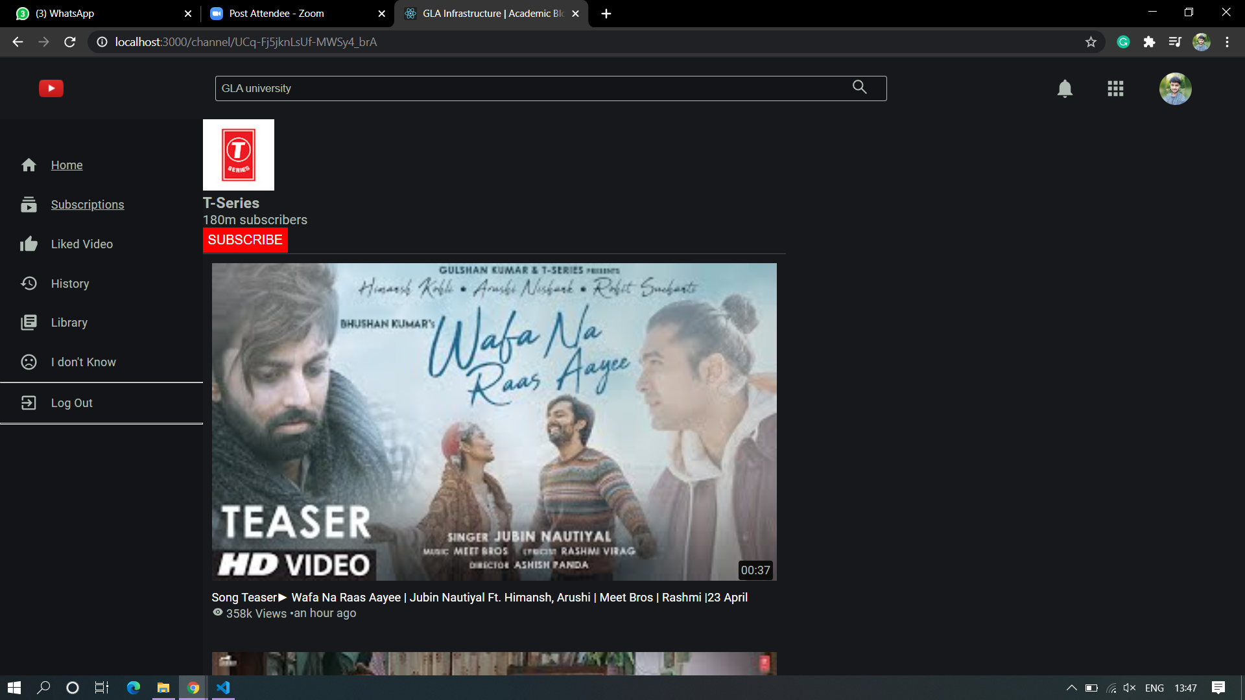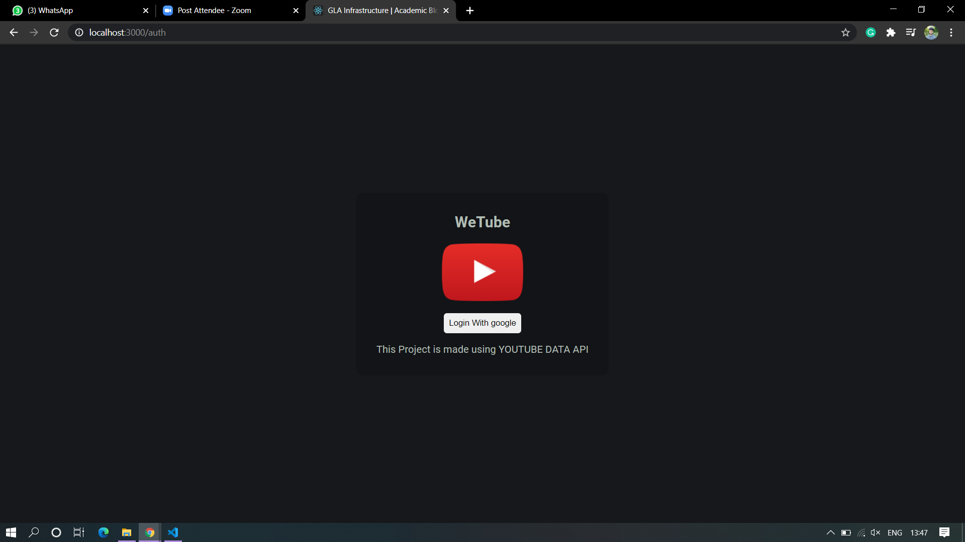

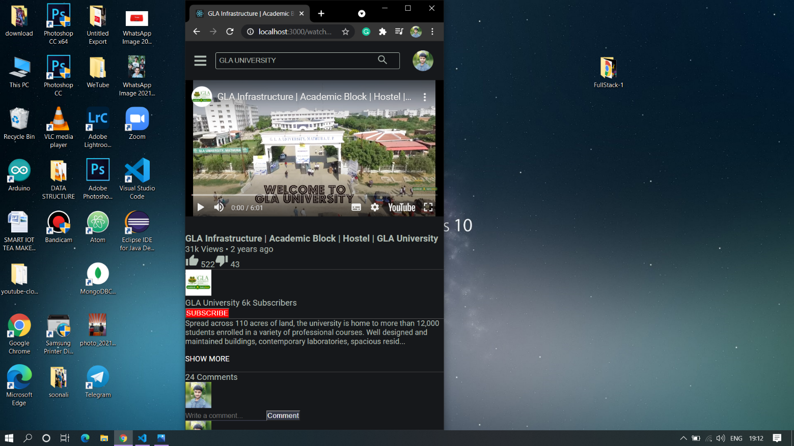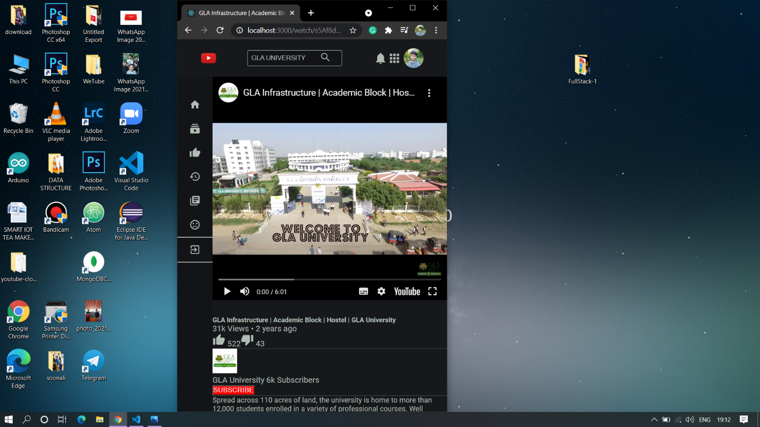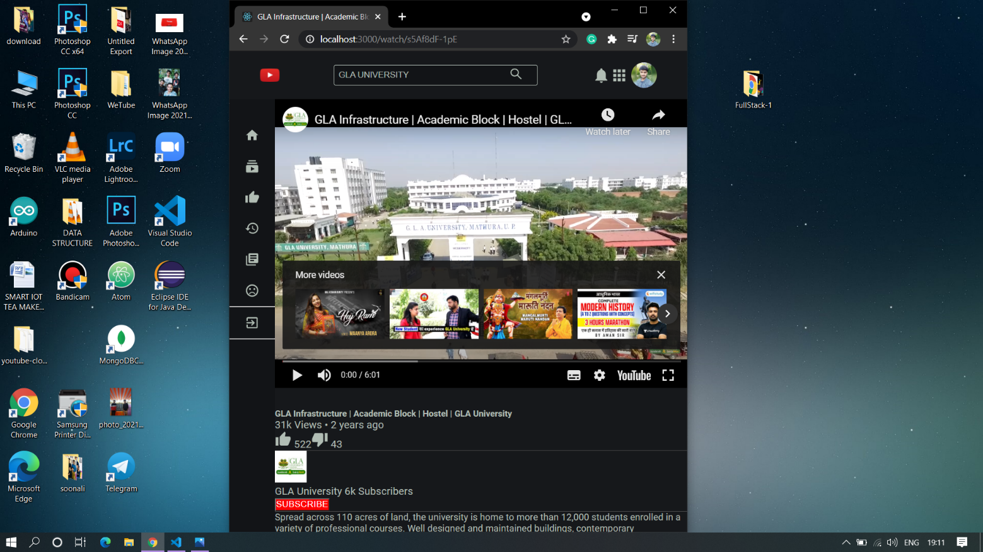

**7. Future Scope:**

1. Since this project works on a local server, in future we can deploy it globally so different users from any part of the world can stream the video.
2. We can add own Database in the application which enable user to upload their own videos, and create their own channel.

**References:**

* <https://nodejs.org/en/>
* <https://reactjs.org/>
* <https://redux.js.org/>
* <https://developers.google.com/youtube/v3>
* [**https://www.geeksforgeeks.org/**](https://www.geeksforgeeks.org/)
* <https://youtu.be/JnvKXcSI7yk>
* <https://www.youtube.com/watch?v=poQXNp9ItL4>
* <https://www.youtube.com/watch?v=RGKi6LSPDLU>

**Faculty Guideline:**

**Mr. Vinay Agrawal**